Design and Implementation of a Fire-Fighting Drone Using a Sound-Wave Mechanism

Ahmed Swaroar Arnob
Graduate Student
Dept of CSE , Jahangirnagar University

Abstract
Firefighting remains a critical challenge, especially in environments where conventional suppression methods are difficult or hazardous to deploy. This study presents the design, development, and evaluation of a novel fire-extinguishing system that integrates low-frequency sound waves with UAV platform. Harnessing the mechanical properties of sound, particularly in the 50–65 Hz range, the system aims to displace oxygen and reduce temperature at the combustion site, effectively disrupting the fire tetrahedron. A custom-built quadcopter equipped with a sonic extinguisher was developed and tested on Class A fires. Experimental results validate the theoretical principles, confirming the system's ability to suppress flames; however, significant performance degradation was observed when the extinguisher was drone-mounted due to aerodynamic interference and vibrational noise. The findings highlight the potential of sonic extinguishing as a clean, chemical-free solution for firefighting, while also emphasizing the need for further optimization in UAV integration, noise control, and adaptive system design. This work contributes a foundational step toward the realization of drone-based acoustic fire suppression in real-world applications.

1. Introduction
Fire disasters pose a persistent and devastating threat globally. According to the latest WHO data published in 2020, fire-related deaths in Bangladesh reached 1,271, accounting for 0.18% of total deaths [1]. This number could be significantly minimized by developing modern solutions capable of fighting fire more efficiently. To understand firefighting, one must first understand fire itself. Fire is a chemical chain reaction involving a fuel source, oxygen, and heat, often visualized as the fire tetrahedron [2]. To extinguish a fire, at least one of these four elements must be removed.
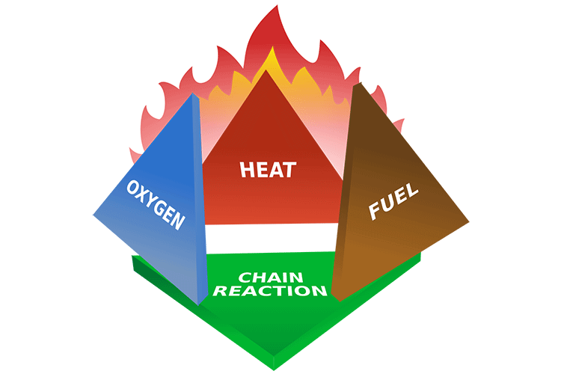

Fires are categorized into different classes based on the fuel source [3]:
- Class A: Wood, paper like solid materials.
- Class B: Liquids or gases like Alcohol, ether, Gasoline, or grease.
- Class C: Flammable electrical equipment.
- Class D: Flammable combustible metals such as sodium, titanium, or magnesium.
- Class K: Fires involving cooking oils and greases.
Conventional extinguishing methods like dry chemicals, foams, and water are effective in specific situations [4]. However, this project proposes the use of sound waves as a clean, efficient, and versatile method to extinguish multiple fire types.

1.1 The Scientific Principle of Sonic Extinguishing
A sound wave is a longitudinal pressure wave that travels through a medium by creating alternating regions of high and low pressure. This mechanical property can be harnessed for firefighting in two primary ways:
- Oxygen Displacement: As a mechanical wave, sound physically displaces the medium it travels through—in this case, the air containing oxygen. The vibrations push oxygen away from the fuel source, disrupting the "oxygen" side of the fire tetrahedron and starving the combustion reaction.
- Cooling Effect: Gay-Lussac’s Law states that P∝T. The low-pressure regions created by the sound wave cause a corresponding drop in temperature. This cooling effect helps remove the "heat" element from the fire tetrahedron, further suppressing the fire.
In this study, we will utilize a drone to deploy this sound wave technology, aiming to eliminate fire by leveraging the physical displacement property of sound.

2. Literature Review

2.1 Challenges in Conventional Fire Safety and Disaster Management
Numerous studies underscore critical deficiencies in current fire safety paradigms. In industrial sectors, particularly in developing countries like Bangladesh, fire safety measures are often alarmingly inadequate. Md. Tazmul Ahosan Azad et al. [5] found that many industries lack fundamental firefighting equipment such as alarms, smoke detectors, fire-resistant doors, and clearly defined emergency exit routes. This situation is echoed in the Readymade Garment (RMG) sector, where non-compliant factories present greater risks to workers [6].
Beyond industrial settings, high-density urban areas face unique vulnerabilities. Rian Wulan Desriani et al. [7] emphasize that fire disasters in such zones necessitate a deeper exploration of community resilience and preparedness. These studies collectively establish a clear need for more effective, responsive, and technologically enhanced approaches to fire safety.

2.2 Unmanned Aerial Vehicles (UAVs) in Firefighting
UAVs, particularly quadcopters, have emerged as versatile tools with significant potential in firefighting due to their maneuverability and ability to access hazardous areas. The fundamental design involves a stable configuration with four rotors, offering advantages in hovering and close-target operations [8, 9]. Key components include BLDC motors, flight controllers (like APM or Pixhawk), and payload capabilities [10, 20].
The application of UAVs directly to firefighting missions is a rapidly evolving field. VOJTECH SPURNY et al. [12] proposed a system for autonomous extinguishing of indoor fires, addressing challenges like building entrance detection, multi-modal localization, and interior motion planning. Similarly, Hailong Qin et al. [15] presented a UAV system for outdoor firefighting featuring a self-designed quadcopter with a water transmission system. These systems demonstrate the potential for UAVs to autonomously navigate complex environments and deliver fire suppressants.

2.3 Novel Fire Suppression: Sonic Extinguishing Technology
Acoustic wave technology represents an innovative, non-chemical, and water-free approach to fire suppression. Multiple studies have explored the capacity of the low-frequency sound waves to blow off flames. Sonali Jain, Manan Luthra et al. [13] found that small fires could be extinguished at limited distances using frequencies between 40Hz and 60Hz. Further research confirmed that low frequencies (optimally 50-70Hz) are most effective, theoretically due to the extended period of low oxygen concentration around the fire source caused by the sound wave [14].
Despite its potential, sonic extinguishing faces challenges. A significant issue is the loud low pitched noise generated can be hazardous. Bong-Young Kim and Myung-Jin Bae [18] investigated this, confirming that a special acoustic lens combined with Active Noise Control (ANC) techniques can reduce side noise by a substantial 32-40dB, making the technology safer.

2.4 Advanced Technologies for System Optimization
The integration of AI and ML is enhancing both fire detection and performance of novel extinguishing systems. Aarthi V et al. [16] proposed a platform using AI and computer vision to recognize and detect smoke and fire from video feeds. For sonic extinguishers, MURAT KOKLU and YAVUZ SELIM TASPINAR [23] utilized machine learning models trained on experimental data to determine the extinguishing status of fuel flames with high accuracy (97.06%), forming a potential decision support system to optimize parameters like frequency and distance.

3. Objectives
Primary objectives are:
- To analyze the efficiency of using drones in firefighting with a sound wave-based mechanism.
- To compare the fire extinguishing capacity of the sound wave device on different classes and grades of fire.

4. Methodology and System Design
To achieve the project objectives, a custom-built quadcopter drone will be integrated with a sonic extinguisher payload. The components for this system are detailed below.

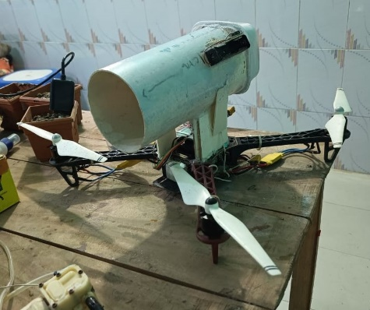

4.1 Drone assembly
Equipment | Description
Motor | EMAX 935 KV Brushless Motor (12V)
ESC | Emax BL Heli 40A, 2-4S
Frame | F450 330mm Glass fiber
Flight controller | APM 2.8, 5V Input
Transmitter | RadioLink AT9S, 12V
Receiver | R9DS 5V
Battery | Tattu 3000mAh, 12V, 45C
The drone was constructed by first assembling the F450 330mm Glass fiber frame to serve as the main chassis. The four EMAX 935 KV Brushless Motors were then securely mounted onto the arms of the frame. Corresponding Emax BL Heli 40A ESCs were connected to each motor and affixed to the frame arms.
The APM 2.8 flight controller was mounted at the center of the frame. The ESCs and the R9DS 5V receiver were then connected to the appropriate input/output pins on the flight controller. The receiver was bound to the RadioLink AT9S transmitter to establish a control link.
For the power system, the Tattu 3000mAh, 12V battery was connected to the ESCs to power the motors, while a 5V regulated output was used to power both the flight controller and the receiver. Finally, all wiring was organized and secured, propellers were installed, and the flight controller's software was configured and calibrated for its first flight.

4.2 Sonic Extinguisher assembly
Equipment | Description
Audio Amplifier Circuit | Custom Built
Speaker | 10 Watt
Vortex Tube | 30 cm
Audio Receiver | Bluetooth Module
Battery | Li-ion battery - 800mAh

An audio amplifier circuit was custom built to drive the system. A 10-watt speaker was selected and housed within a 30 cm vortex tube, which was constructed to channel the sound waves effectively. For wireless signal input, a Bluetooth module was chosen as the audio receiver and was interfaced with the custom amplifier circuit. The entire payload, including the amplifier and Bluetooth module, was powered by an 800mAh Li-ion battery that had been integrated into the system. Finally, all components were assembled and secured to create the finished sonic extinguisher payload.
4.3 Code:

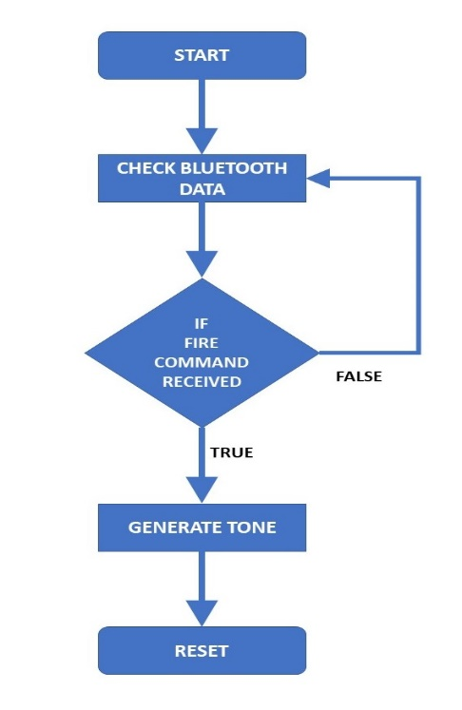
Start: The program begins execution.
Setup Phase (initializeSystem): This is a one-time sequence of operations.
It initializes serial and Bluetooth communication.
It configures the buzzer pin as an output.
It sends a confirmation message to the serial monitor indicating that the system is ready.
Main Loop (loop): After the setup is complete, the program enters an infinite loop where it continuously performs the following actions:
Listen for Command: The system first checks if any data has been sent from a Bluetooth device.
Check Bluetooth Data:
If there is no data, the loop skips to the next check.
If there is data, the system reads it as a string.
Check Command String:
The received string is checked to see if it matches "FIRE" (case-insensitive).
If it matches, a flag named fireCommandReceived is set to true. Otherwise, nothing happens.
Check Fire Flag: The program then checks the status of the fireCommandReceived flag.
If the flag is false, the loop restarts from the beginning.
If the flag is true, it means the "FIRE" command was received, and the program proceeds to activate the buzzer.
Generate Tone: The generateFireExtinguishTone function is called. It prints a start message, generates a high-frequency (10kHz) sound on the buzzer for 10 seconds, and then prints a completion message.
Reset Flag: After the tone has finished, the fireCommandReceived flag is reset to false to ensure the tone doesn't immediately trigger again. The program then returns to the beginning of the loop to wait for the next command.

5. Validation & Results
5.1 Validation

Validation was done against data from [14] S. Jain, et al., "Performance Evaluation of Sonic Fire Fighting System," in Proc. 2021 ICACCS, pp. 1510-1514.
Frequency | Validation Paper data | Experimental data
48 Hz | 1.8 sec | 2 sec
50 Hz | 1.2 sec | 1.5 sec
55 Hz | 1 sec | 1 sec
60 Hz | 2 sec | 2.5 sec
65 HZ | 2.5 sec | 3 sec

5.2 Performance test
Frequency | Without Drone | With Drone
45 Hz | 2 | 6
50 Hz | 1.5 | 5
55 Hz | 1 | 4
60 Hz | 2.5 | 4
65 Hz | 3 | 5
70 Hz | 4 | 5
75 Hz | 5 | 6
80 Hz | 5 | 6
85 Hz | 6 | 7

6. Discussion

The primary objective of this project was to analyze the efficiency of a drone-based, sound-wave fire-fighting mechanism. The results confirm the fundamental principle of sonic extinguishing, demonstrating its ability to quench small fires. However, the findings also reveal critical challenges related to the practical deployment of this technology on a UAV platform.

The most significant finding is the drastic reduction in performance when the sonic extinguisher was mounted on the drone. The extinguishing time increased by 300% at the optimal frequency of 55 Hz (from 1 second to 4 seconds). This performance degradation can be attributed to several factors inherent to the drone's operation. The powerful downwash from the drone's four rotors likely interferes with the focused vortex of the sound wave, dispersing its energy and weakening the pressure differential required to displace oxygen. Furthermore, vibrations from the drone's motors and frame could disrupt the speaker's performance, leading to a less coherent and effective sound wave.

The validation of our sonic extinguisher against previous research showed a similar performance curve, with peak efficiency in the 50-60 Hz range. However, the calculated errors highlight a sensitivity to specific experimental conditions. The 25.4% discrepancy at 48 Hz suggests that minor differences in speaker wattage, vortex tube geometry, or fuel source can have a substantial impact on efficiency.

This study reinforces challenges identified in the literature. The issue of hazardous low-frequency noise, as noted by Bong-Young Kim and Myung-Jin Bae, becomes even more complex when combined with the noise generated by the drone itself. An integrated solution that incorporates Active Noise Control (ANC) would be essential for making such a device safe for operators. Moreover, the performance drop on the drone platform underscores the potential need for an intelligent control system. The use ML to create a decision support system, as proposed by Murat Koklu and Yavuz Selim Taspinar, could be vital. Such a system could potentially adjust the sound wave's frequency and amplitude in real-time to compensate for the interference from the drone's rotors and environmental factors.

The limitations include the controlled lab environment and the focus on small, Class A fires. The negative impact of the drone on performance indicates that significant design modifications would be required before testing on other fire classes or in a real-world scenario.

7. Conclusion

This project successfully designed, implemented, and evaluated a fire-fighting system that integrates a sonic extinguisher with a quadcopter drone. The research confirmed the underlying principle that low-frequency sound waves, specifically in the 50-65 Hz range, can effectively extinguish small flames by displacing oxygen and creating a cooling effect.

The key finding of this study is the quantifiable challenge of deploying this technology via a UAV. The integration resulted in a significant performance decrease, with extinguishing times increasing by up to 300% compared to static, ground-based tests. This highlights that the aerodynamic and vibratory interference from the drone is a primary obstacle to practical application.

The project contributes a valuable case study to the field of novel fire suppression, demonstrating that while the core technology is sound, its integration with a delivery platform like a drone is not trivial and requires a systems-engineering approach to overcome interference issues.

Future work should focus on three critical areas:

System Integration: Designing a physical shield or modifying the payload's placement to protect the sound wave from the drone's rotor downwash.

Noise Mitigation: Incorporating Active Noise Control (ANC) technology, as suggested in the literature, to address the combined noise hazard from both the sonic extinguisher and the drone.

Intelligent Control: Developing an adaptive control system using machine learning to modulate the sound wave's frequency and power in real-time, compensating for environmental and drone-related interference to optimize performance.

By addressing these challenges, the potential for drone-deployed sonic extinguishers to become a clean, efficient, and responsive tool in modern firefighting can be fully realized.

8. References
- World Life Expectancy, Bangladesh - Fires: https://www.worldlifeexpectancy.com/bangladesh-fires
- Fire Risk Assessment Network, Fire Triangle & Tetrahedron: https://fire-risk-assessment-network.com/blog/fire-triangle-tetrahedron/
- Vanguard Fire & Security, 5 Different Classes of Fires: https://vanguard-fire.com/what-are-the-5-different-classes-of-fires/
- HSEWatch, Methods of Fire Extinguishing: https://hsewatch.com/methods-of-fire-extinguishing/
- M. T. A. Azad, et al., "Risk of Fire Disaster: Consequences on Industry Sectors in Bangladesh," Int. J. of Energy and Sustainable Dev., vol. 3, no. 3, pp. 52-63, 2018.
- M. F. Hossain, "Fire Hazard in Readymade Garment Factories...," J. of the Asiatic Society of Bangladesh, Science, vol. 42, no. 1, pp. 77-93, Jun. 2016.
- R. W. Desriani and P. Samyahardja, "Urban Resilience to Fire Disaster in High Density Urban Area," in Environmental Justice and Urban Resilience, 2020, pp. 202-217.
- O. Tatale, et al., "Quadcopter: Design, Construction and Testing," Int. J. for Research in Eng. App. & Management, vol. 04, 2018.
- D. B. B. V. L. Pritpal Singh, "A survey on design and development of an unmanned aerial vehicle (quadcopter)," Int. J. of Intelligent Unmanned Systems, vol. 4, no. 2, 2016.
- O. I. D. Bashi, et al., "Unmanned Aerial Vehicle Quadcopter: A Review," J. of Comp. and Theo. Nanoscience, vol. 14, pp. 5663-5675, 2017.
- S. Kusmirek, et al., "Dynamic Flight Tracking...," IEEE Access, vol. 12, pp. 109806-109821, 2024.
- V. Spurny, et al., "Autonomous Firefighting Inside Buildings by an Unmanned Aerial Vehicle," IEEE Access, vol. 9, pp. 15872-15890, 2021.
- S. Jain, et al., "Sonic Fire Fighting System," in Proc. 2020 ICCCI, pp. 1-4.
- S. Jain, et al., "Performance Evaluation of Sonic Fire Fighting System," in Proc. 2021 ICACCS, pp. 1510-1514.
- H. Qin, et al., "Design and implementation of an unmanned aerial vehicle for autonomous firefighting missions," in Proc. 12th IEEE ICCA, 2016, pp. 62-67.
- V. Aarthi, et al., "Acoustic Wave-Based Forest Fire Extinguisher and Detection Using Machine," Int. J. of Eng. App. Sciences and Tech., vol. 4, no. 10, pp. 196-202, Feb. 2020.
- M. A. A. Waheed, "Approach to Fire-Related Disaster Management in High Density Urban-Area," Procedia Engineering, vol. 77, pp. 61-69, 2014.
- B.-Y. Kim and M.-J. Bae, "A Study on Sound Noise Control Method of Sound Fire Extinguisher with Wind," Int. J. of Eng. Res. and Tech., vol. 12, no. 6, pp. 765-769, 2019.
- R. Yadav, et al., "Designing of Fire Extinguisher Based on Sound Waves," Int. J. of Eng. and Adv. Tech., vol. 9, no. 4, pp. 927-930, Apr. 2020.
- C. A. Amadi, "Design and Implementation of Model Predictive Control on Pixhawk Flight Controller," M.Eng. thesis, Stellenbosch Univ., 2018.
- J. Gazdag, "Modeling of the acoustic wave equation with transform methods," Geophysics, vol. 46, no. 6, pp. 854-859, Jun. 1981.
- R. M. Alford, et al., "Accuracy of finite-difference modeling of the acoustic wave equation," Geophysics, vol. 39, no. 6, pp. 834-842, Dec. 1974.
- M. Koklu and Y. S. Taspinar, "Determining the Extinguishing Status of Fuel Flames With Sound Wave by Machine Learning Methods," IEEE Access, vol. 9, pp. 86207-86216, 2021.
- B.-Y. Kim, et al., "A Study on a Suitability of Sound Fire Extinguisher in Duct Environment," Int. J. of App. Eng. Res., vol. 12, no. 24, pp. 15796-15800, 2017.

